DSS: Decision Support System. These systems assist decision-makers in understanding complex problems, exploring options, and making informed choices.

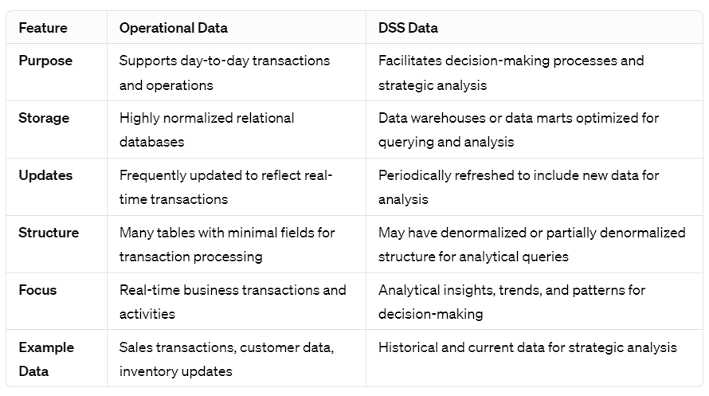

**A Data Warehouse** is separate from DBMS, it stores a huge amount of data, which is typically collected from multiple heterogeneous sources like files, DBMS, etc. The goal is to produce statistical results that may help in decision-making. For example, a college might want to see quick different results, like how the placement of CS students has improved over the last 10 years, in terms of salaries, counts, etc. 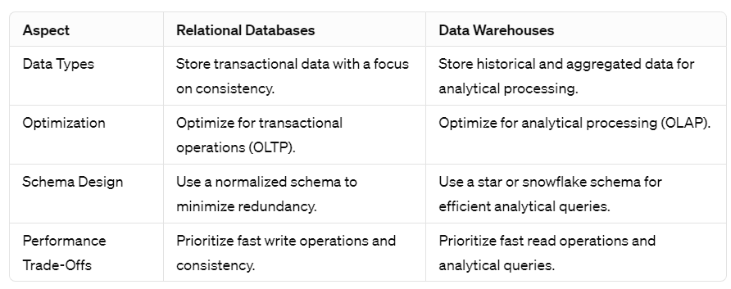

**Need for Data Warehouse:**

* *Storage Capacity:* Ordinary databases have limited capacity and are suitable for storing data up to MBs to GBs. However, for large-scale data storage, especially in the terabyte range, a Data Warehouse is necessary.
* *Analytics Requirements:* Transactional databases are primarily designed for transaction processing and lack features for extensive analytics. A Data Warehouse provides a centralized platform for organizing, understanding, and analyzing historical data to derive strategic insights and analyze trends.
* *Enhanced Business Analytics:* They centralize all past data and records, enabling comprehensive analysis to enhance business understanding and decision-making.
* *Faster Queries:* Data Warehouses are optimized for handling large queries, resulting in faster query execution compared to traditional databases.
* *Improved Data Quality:* Data Warehouse systems ensure data quality by storing data from various sources without interference, thereby maintaining data integrity. Data Warehouse teams are responsible for addressing any data quality issues that arise.
* *Historical Insight:* Data Warehouses retain historical data, providing a rich source of info for analysis & extracting insights about past business performance & trends.

**The information flow mechanism** in a data warehouse involves the following:

* *Data Extraction:* Data is extracted from various sources such as databases, spreadsheets, and external systems.
* *Data Transformation:* Extracted data undergoes transformation processes including cleaning, filtering, and formatting to ensure consistency and usability.
* *Data Loading:* Transformed data is loaded into the data warehouse, where it is organized and stored in a structured format.
* *Data Storage:* Data warehouse stores historical and current data, providing a centralized repository for analysis and reporting.
* *Data Access and Analysis:* Users can access data from the warehouse using query and reporting tools to perform analysis, generate insights, and make informed decisions.
* *Data Presentation:* Analyzed data is presented to users through reports, dashboards, and visualizations for easy interpretation and decision-making.

**Metadata** is simply defined as data about data. It means it is a description and context of the data. It helps to organize, find and understand data. Metadata in operational systems primarily serves IT needs, metadata in data warehouses is indispensable for enabling users to explore, understand, and utilize the data effectively for analysis and decision-making purposes.

* Metadata in a DW is essential for users to understand & navigate contents effectively.
* Users require sophisticated methods for browsing & examining DW contents.
* Understanding the meanings of data items is crucial to prevent users from drawing incorrect conclusions during analysis.
* Adequate metadata support is essential for users to derive insights and make informed decisions from the data warehouse.